MAP SERVICES
Now it’s easier than ever to add a WMS map service to your GIS software. Use the addresses below to connect, or download connection files for QGIS and ArcMap.
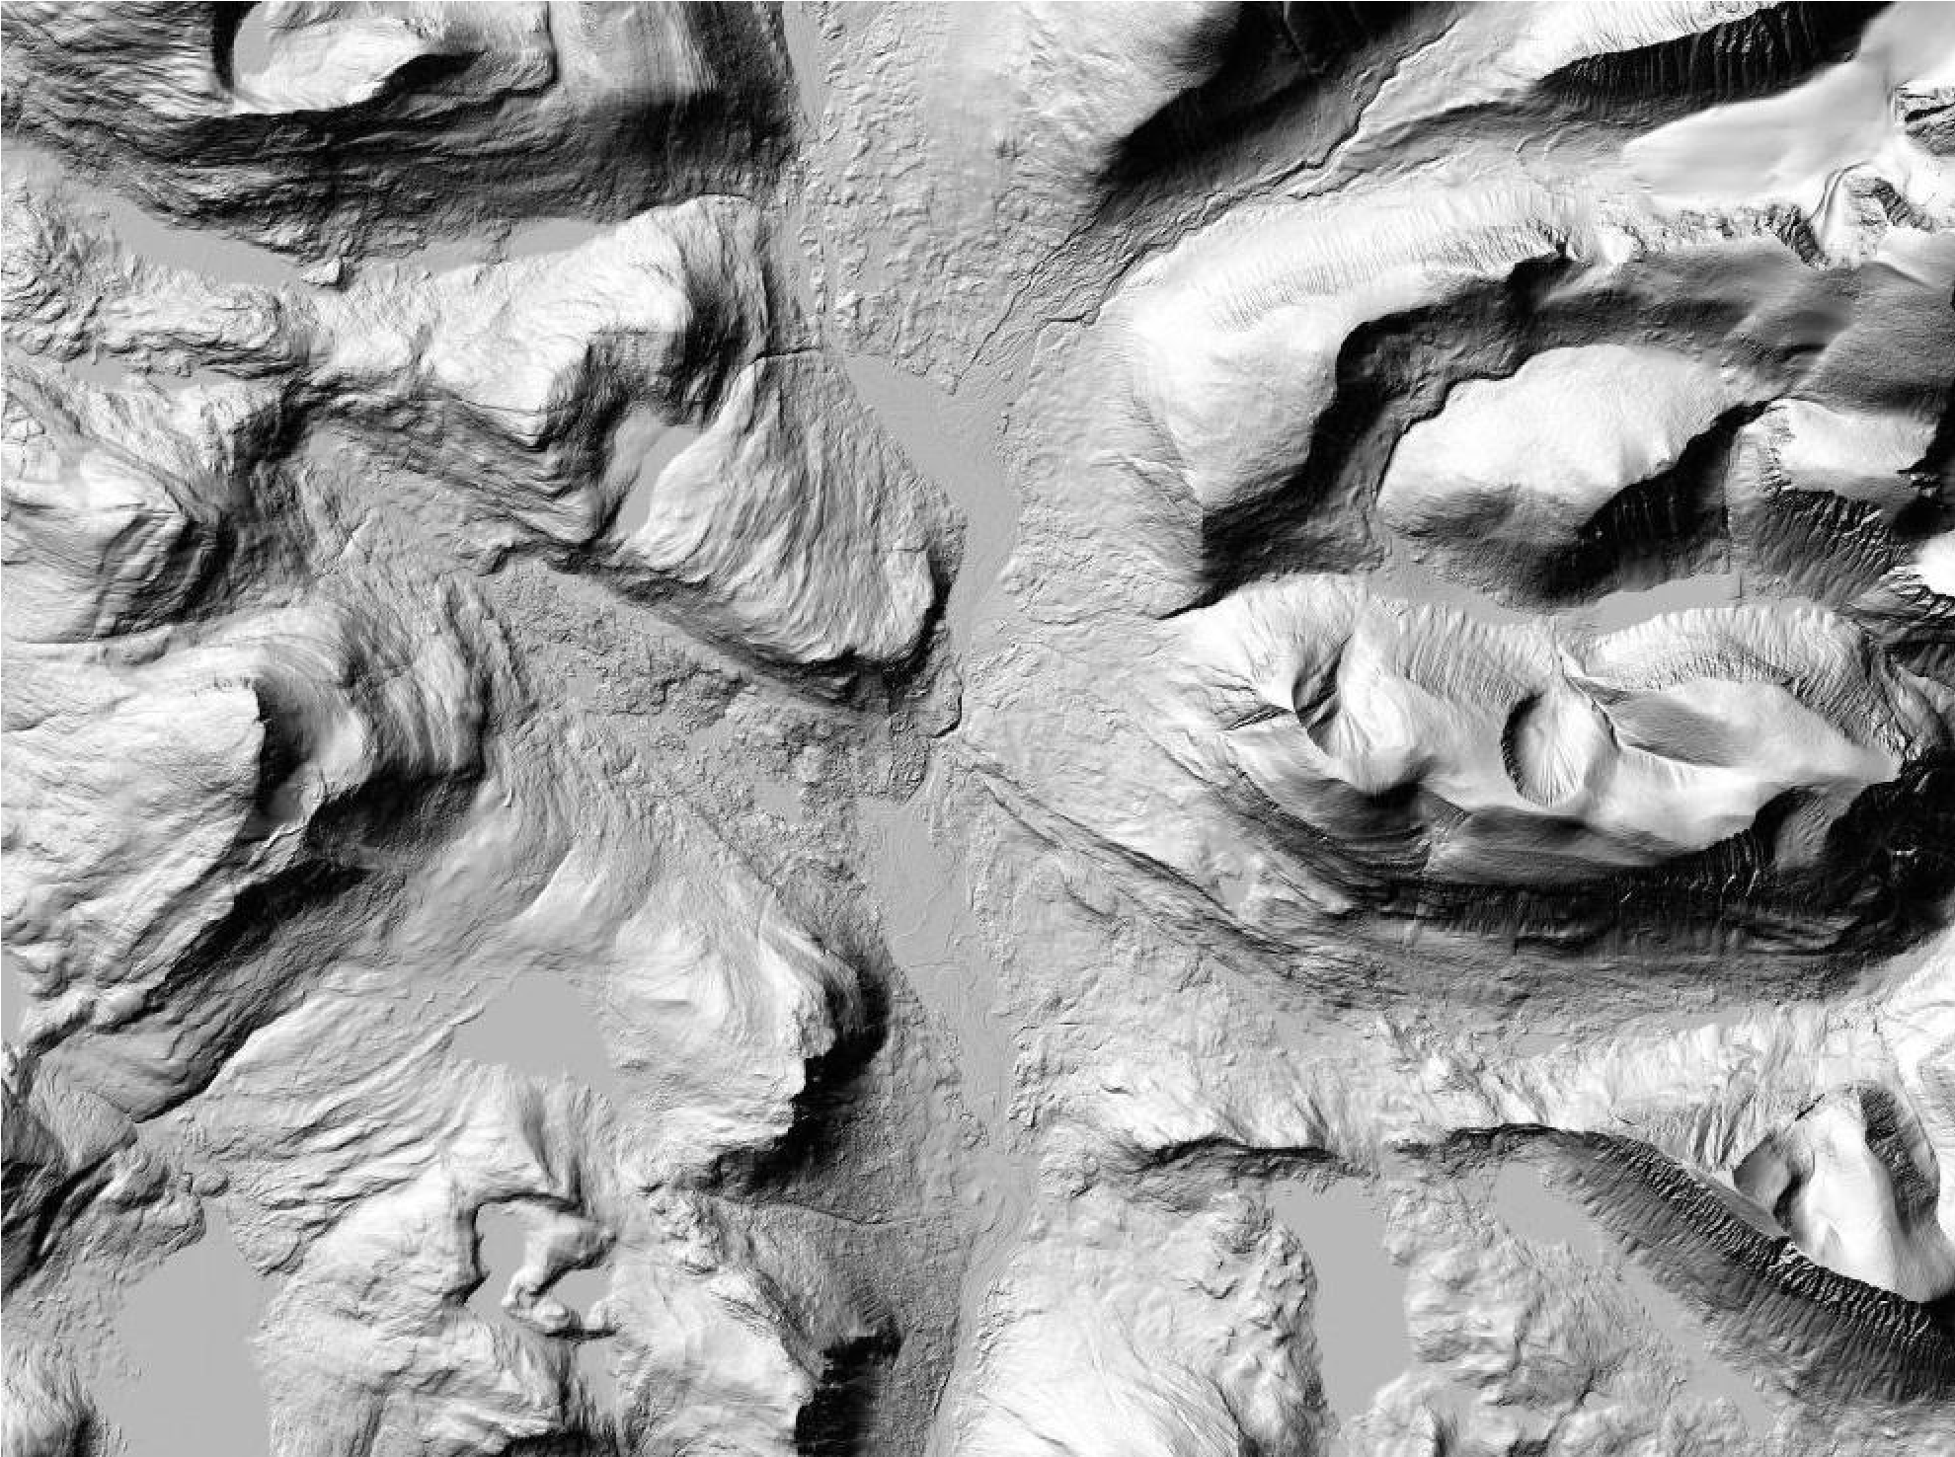
Hillshade over the Kebnekaise area. From The Höjdmodell WMS service.
_{© Lantmäteriet}
What is a WMS map service?
WMS (Web Map Service) is a standardised way of connecting to a map server over the Internet. Once connected, you will have access to seamless georeferenced map images which can be combined with other datasources, on the net or on your computer. Most modern GIS software can connect to and display WMS services.
What can I do with it?
What can I do with it?
Two examples: You can use the map services as background map and display your own data on top. Or you could manually interpret aerial photos to create or update spatial data.

Which view services are available?
Use the following links to connect to the services using your favourite GIS software.
Allmänna kartor (General maps) http://hades.slu.se/lm/allmannakartor/wms/v1?
Fastighetsindelning (Property boundaries) http://hades.slu.se/lm/fastighet/wms/v1.1?
Höjdmodell (Elevation model) http://hades.slu.se/lm/hojdmodell/wms/v1.1?
Ortofoto (Orthoimagery) http://hades.slu.se/lm/ortofoto/wms/v1.3?
Ortofoto årsvisa (Orthoimagery Yearly images) http://hades.slu.se/lm/ortofoto-ar/wms/v1.2?
Planer, bestämmelser och rättigheter (Plans, rules and rights)
http://hades.slu.se/lm/pbr/wms/v1.1?
Topografisk webbkarta (Topgraphical site map) From the Ortofoto WMS service. http://hades.slu.se/lm/topowebb/wms/v1?
Topografisk webbkarta skiktindelad (Topgraphical site map, layer divided)
http://hades.slu.se/lm/topowebb-skikt/wms/v1.1?
Topografisk webbkarta cache (Topographical site map, higher performance cache version)
http://hades.slu.se/lm/topowebb/v1.1/wmts? request=GetCapabilities&version=1.0&service=wmts
Uppdaterad Sjökortsbild från Sjöfartsverket (Sea charts)
http://hades.slu.se/sfv/?
Alternatively you can download connection files for QGIS and ArcMap from this link:
http://salix.slu.se/download/wmsConnect
For more information about the map services, see the Lantmäteriet web site.
Can anyone access these services?
No. Access is restricted to computers connected to networks (internet domains) belonging to universities which have signed the FUK agreement. See more about the agreement here:

Where can I find other WMS services?
Many authorities in Sweden are using WMS to publish data. The best place to search for and preview open services is Geodataportalen:
https://www.geodata.se/GeodataExplorer/index.jsp?loc=sv in Swedish
https://www.geodata.se/GeodataExplorer/index.jsp?loc=en in English
Can I download the source data for the services?
Yes, if you are a student or employee at a university that have signed the FUK agreement. Most source databases for the Lantmäteriet map services, including data from SCB (Statistics
Sweden), SGU (Geological Survey of Sweden) and Sjöfartsverket (Swedish Maritime Administration), are available from the GET download service at http://maps.slu.se
Availability and planned maintenance of Lantmäteriet services
For service level commitment and maintenance of the IT infrastructure shared by all services please see this page.
More questions?
get.support@slu.se
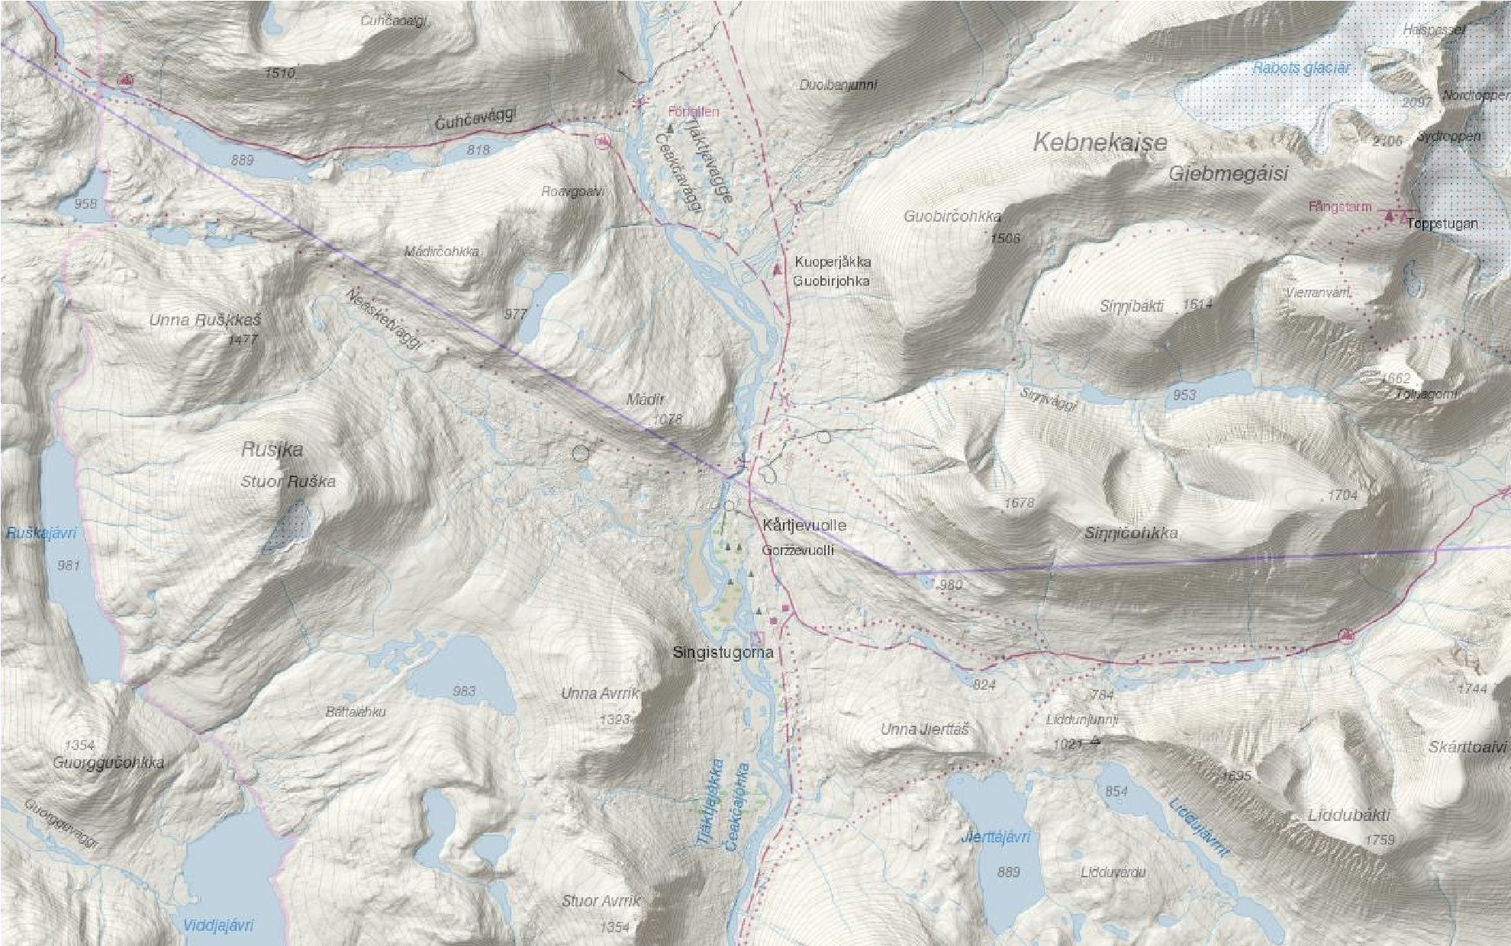
Combination of the Topografisk webbkarta and
Höjdmodell WMS services.
© Lantmäteriet

